
ClockInPro Work Hours & Payroll Tracker

Course: JAVA PROJECT
Course Code: CAP477
Group No: D2523

Submitted by:  Prashant Patil (12527088)  Sachin Jangra (12500231)  Kileshwar (12518653) | Submitted to:  Dr. Girish Kumar  UID: 21706

School of Computer Applications,
Lovely Professional University,
Punjab

Table of Content
1. Acknowledgement 2
2. Overview 4
3. Established 4
4. Introduction to Existing System 4
5. Scope of Existing System 5
6. Future Scope of Existing System 5
7. Problem analysis 6
8. Product definition of new system 6
9. Feasibility study for new system 7
10. Project planning for new system 7
11. Software Requirement Analysis 8
11.1. Introduction 8
11.2. General Description 8
11.3. Specific Requirements 9
12. System Design 9
13. Flow Charts for new system 10
14. DFD for new system 11
15. ER Diagram of new system (Database) 12
16. References 13

1. Acknowledgement
We would like to express our sincere gratitude to Dr. Girish Kumar, our project mentor, for his continuous support, valuable guidance, and encouragement throughout the development of this project. His timely advice and constructive feedback helped us overcome challenges and complete this work successfully.
We are also thankful to the faculty of the Department of Computer Applications, Lovely Professional University, Phagwara, Punjab, for their support and guidance during our academic journey.
Prashant Patil (12527088), Sachin Jangra (12500231), Kileshwar (12518653)

Name of the Student
- Prashant Patil (12527088)
- Sachin Jangra (12500231)
- Kileshwar (12518653)

Date: 15 Apr 2026

2. Overview
The manual tracking of employees' working hours and salaries can take much time and may be prone to errors. It is difficult for enterprises to maintain proper attendance records and make timely salary payments. There is an urgent need for software that will help record the log-in and log-out timings of the employees, compute their salaries, and prepare monthly reports. ClockInPro software can provide the desired solution.

3. Established
At present, many small and medium enterprises conduct attendance and payroll processing by means of ma nual registers, Excel documents, or spreadsheet applications. The employees are expected to register their presence physically on paper and the manager will need to sum up the overall working hours at the end of each month. However, the procedure takes much time and entails numerous errors. The data can get either lost, altered, or inaccurately recorded, which results in miscalculations and employee discontent. While some big companies employ such expensive HR management software as SAP, BambooHR, and ADP, these programs cannot be afforded by small businesses or educational establishments because of their high price and sophisticated features. The software needs professional IT staff to operate and requires powerful technical support. Additionally, most applications are web-based or cloud-based and are not applicable for areas with limited Internet connectivity. Thus, there is an obvious necessity for development of an affordable desktop application for attendance and payroll processing.

4. Introduction to Existing System
Prior to the existence of ClockInPro, the attendance and salary processing of employees were done using conventional and manual processes. The companies would use paper registers, punch cards, or even an excel sheet to record the number of hours that employees work. Once the month ended, the managers or Human Resource staff members would manually tally the hours and compute the employees' payrolls, then issue salary slips. Not only did this process take too much time, but it was also entirely reliant on human input. Any error made during the data entry process would result in wrong salary payments, which would frustrate employees. In addition, there was no database that held the attendance information for retrieval purposes.

5. Scope of Existing System
The scope of the existing system was quite narrow in its outlook and rudimentary in nature. The system only included basic functions like maintaining registers of employees' attendance and manually computing their salaries once a month. The system was restricted within one department or one geographical area alone and could not be extended to more than one branch or office. It did not have the function of recording time of log-in and log-out of employees. Calculations of salaries were done manually using basic calculations or through Excel sheets. This process was error-prone and inconsistent. There were no functions of generating reports, thus requiring managers to generate these reports on their own each month. The existing system did not have any kind of security features, as data could easily be accessed through unsecured means.

6. Future Scope of Existing System
Future scope of the existing manual system is very limited since it is not possible to upgrade or expand it without having to implement a software solution from scratch. It will be incapable of supporting online data entry, multi-user capability, remote connectivity, and other types of automation without a complete overhaul into a computerized application. It is not possible for the system to be integrated with cloud services, notifications, and other HR applications that companies now depend on for effective employee management. It is not possible to have advanced capabilities such as those for overtime management, taxation, leave balances, and payroll summaries per department through the current system. Improving the system will simply entail having to build another application, which will be the same goal of the proposed ClockInPro system.

7. Problem analysis
An extensive analysis of the current manual attendance and payroll process highlights a number of serious issues that decrease productivity and cause data inaccuracies. Firstly, the manual registration of log in and log out data is subject to the errors made during its recording and can easily be falsified by either staff members or their superiors. Payrolls calculated using the manual method lack consistency, and errors are frequently encountered when doing math, which causes employees to receive either too much or too little money as salary. As there is no database involved in the process at all, data storage poses serious problems since they are kept in paper documents and Excel sheets, making searching, updating, and restoration impossible in case some information is lost. No access control measures are used in the process, which allows any individual who has access to this data to manipulate it without leaving any traces whatsoever. Lastly, compiling monthly salary reports manually each month is extremely time-consuming.

8. Product definition of new system
ClockInPro is a desktop application that is known as Work Hours & Payroll Tracker that was programmed using Core Java. The Graphical User Interface (GUI) of the application is made using Java Swing while the JDBC was used for connecting the application to the MySQL database. This application makes sure that everything about recording attendance, calculating total hours worked, paying employees their salary depending on their hourly rate, and payroll reporting is made easier through this automated process. Two different accounts are provided for the application, namely, Manager and Employee. These different users have different credentials that allow for restricted access since sensitive information needs to be secured for security purposes. Users of this application will be able to Clock In and Out just by clicking one button where the application will make sure that the time is recorded instantly inside the MySQL database with no need for manual inputs. Using the Payroll module, the application will automatically calculate the total hours worked and gross salary of every employee for the month.

9. Feasibility study for new system
Technical Feasibility
- Java, Swing, JDBC, and MySQL are robust technologies that have extensive documentation and are free to use. These technologies can be easily integrated using any generic IDE like NetBeans or Eclipse without paying extra costs.
Economic Feasibility
- The whole system has been designed with open source software, making it almost cost-free to develop. It helps in saving a lot of money by avoiding human errors in payroll management and cutting down the number of hours required for manual record keeping and salary calculations each month.
Operational Feasibility
- The Java Swing-based GUI is very easy to understand for the manager and employees. Only limited training will be needed, making it quick to deploy in any small to medium-sized firm.
Schedule Feasibility
- This project has been broken down into five clear phases — design, database creation, GUI creation, implementation, and testing. It can easily fit into a typical university semester schedule.

10. Project planning for new system
The ClockInPro development process is divided into five carefully orchestrated phases to facilitate effective execution and timely delivery within the semester period. Phase 1 involves the collection of the requirements for the software, both functional and non-functional, by conducting consultations with the stakeholders and analyzing the current system. Phase 2 deals with the design process, which involves developing an entity relationship diagram (ERD), data flow diagram (DFD), flowchart, and wireframe of the graphical user interface (GUI) for the entire architecture of the proposed software. Phase 3 represents the implementation phase, in which the development of Java Swing forms, database creation using MySQL, and JDBC connection to link the front-end and back-end operations are executed. Phase 4 includes testing procedures, which consist of unit tests of the individual modules, integration tests between the modules, and acceptance tests to validate the fulfillment of all requirements. Phase 5 concerns the deployment of the developed software on a computer and the preparation of documentation of the entire project.

11. Software Requirement Analysis

11.1. Introduction
The main objective of the ClockInPro application is to automate the process of collecting employee attendance data and calculating salaries from an unreliable manual system into a fully automatic desktop program. The software will provide a platform where all human error involved in collecting attendance data and calculating salaries will be eliminated through an automatic program running on a Java-based GUI linked to a MySQL database. This product is mainly aimed at small to medium-sized businesses where implementing a dedicated Human Resource Information System (HRIS) may be expensive; hence, payroll automation is necessary for such firms. The application ensures that every single minute of employees' working time is accurately accounted for and stored, which will then be used to calculate monthly salaries.

11.2. General Description
ClockInPro is a single desktop application that can run on any computer provided there is a JDK and a MySQL server locally installed on that computer, hence it does not need an internet connection nor any other third party software. The system comprises of four components: the Employee Module, Attendance Module, Payroll Module, and Report Module. The employee module enables management of the employee profiles including login credentials; the attendance module helps in the logging in and logging out of employees. The payroll module automatically calculates employees' salaries every month and the report module shows formatted information about payroll. All user interfaces are implemented using Java Swing providing an intuitive window based interface with forms, tables, buttons, and labels which makes it convenient for everybody to use. All data from the GUI will be automatically stored in a MySQL relational database using JDBC. The system has role-based security such that only managers have access to all records whereas employees have access to their attendance records and salary computations.

11.3. Specific Requirements
- Login/Logout Mechanism: Secure login and logout mechanisms are implemented for both the employee and manager.
- Timestamp Entry: Automatic entry of timestamps upon employee clock-in and clock-out.
- Hour Tracking: Automatic calculation of total number of hours worked daily and accumulation of those hours over the course of the month.
- Gross Salary Calculation: Automatic calculation of gross salary based on the total number of working hours and the defined hourly wage.
- Payroll Report Creation: Generation of monthly payroll report which can be displayed on screen.
- Security and Access Control: Role-based access control allows the employee to view and modify personal details and prevents any other access. JDBC queries are used for secure interaction with the database to avoid SQL injections.
- Reliability, GUI and Performance: Employee data is reliably stored within the MySQL database without being lost. GUI is user-friendly and intuitive even to people who do not have technical expertise. Handling at least 50 employee entries without any problem.

12. System Design
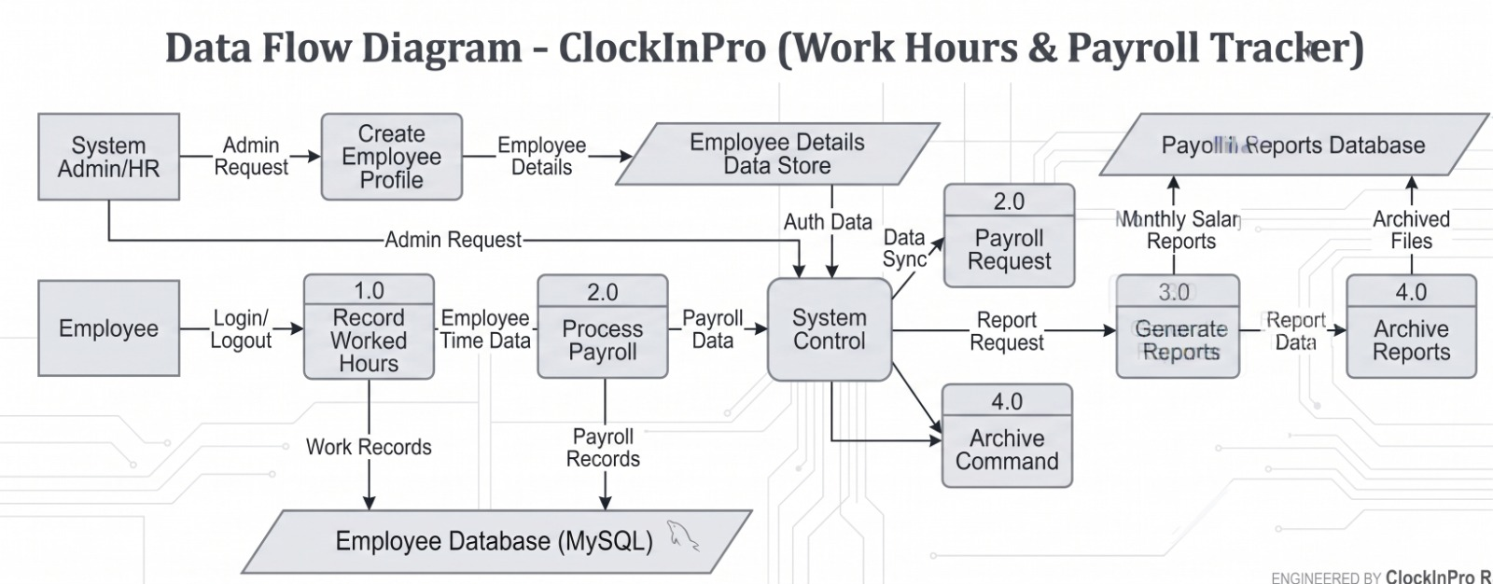

13. Flow Charts for new system
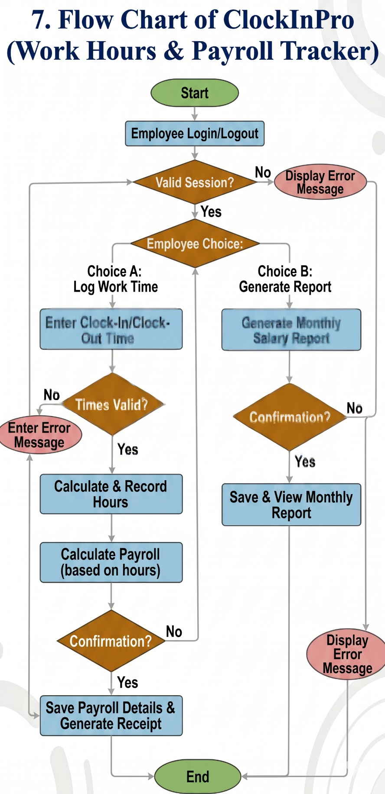

14. DFD for new system
The Level 0 DFD (Context Diagram)
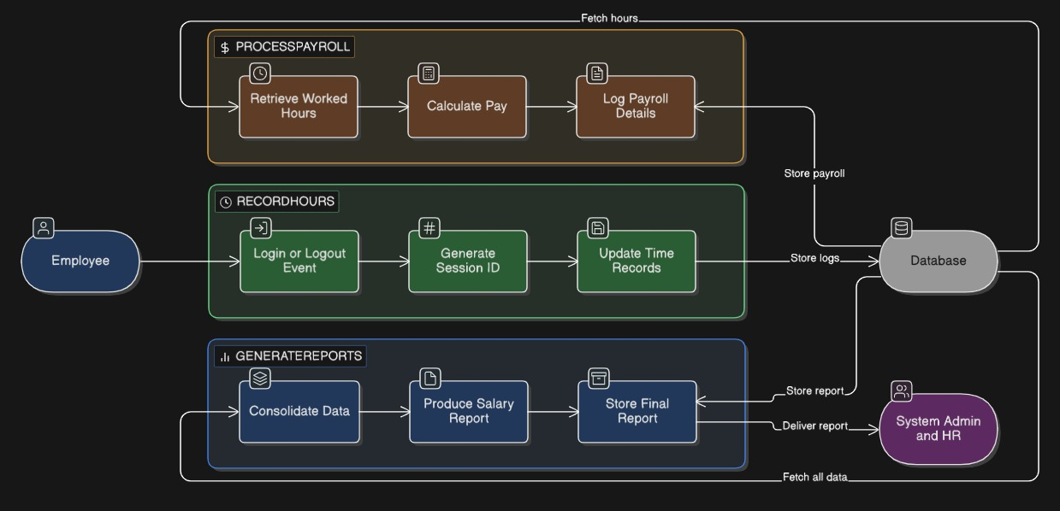

The Level 1
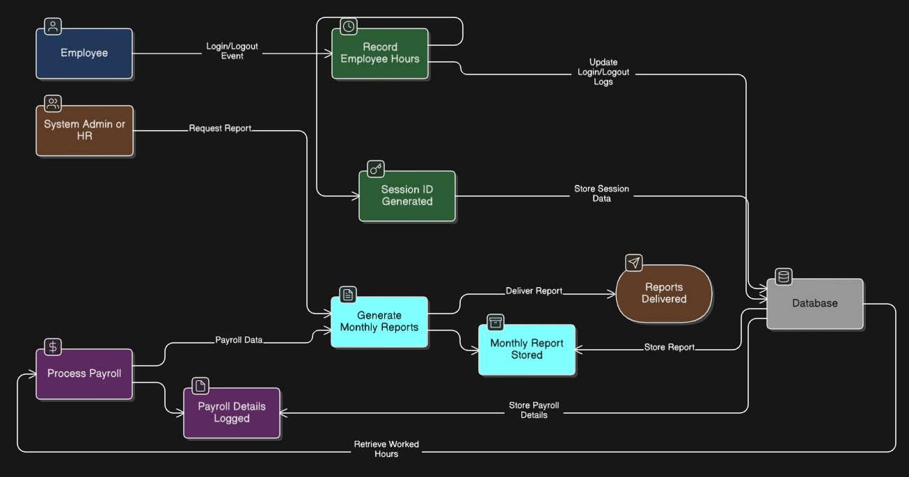

15. ER Diagram of new system (Database)
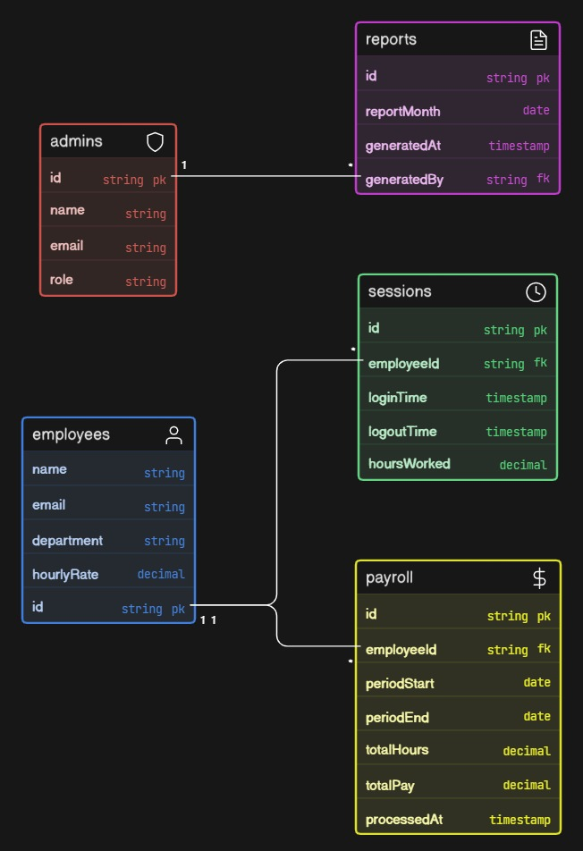

16. References

[1], [2], [3], [4], [5], [6]
[1] B. Trilaksono, … S. S.-2024 7th I., and undefined 2024, “Personnel System Mobile Application Design Payroll: Case Study for MSME,” ieeexplore.ieee.org, Accessed: Apr. 15, 2026. [Online]. Available: https://ieeexplore.ieee.org/abstract/document/10748186/
[2] A. A. Olalekan, S. Wilson, W. S.-I. 3rd International, and undefined 2022, “How reliable are administrative reports of paid work hours?,” Elsevier, 2023, Accessed: Apr. 15, 2026. [Online]. Available: https://www.sciencedirect.com/science/article/pii/S0927537122000240
[3] F. Tandrio, M. F.-J. (Jurnal I. Pengetahuan, and undefined 2026, “WEB-BASED PAYROLL SYSTEM DEVELOPMENT USING THE PROTOTYPING METHOD AND STRUCTURED DATABASE DESIGN,” ejournal.nusamandiri.ac.id, Accessed: Apr. 15, 2026. [Online]. Available: https://ejournal.nusamandiri.ac.id/ejurnal/index.php/jitk/article/view/7044
[4] P. Khorsand, T. P.-A. Sciences, and undefined 2023, “Implementation of a working time recording system as a digital management tool in public administration,” mdpi.com, Accessed: Apr. 15, 2026. [Online]. Available: https://www.mdpi.com/2076-3387/13/12/253
[5] R. S.-I. J. of A. intelligence and and undefined 2025, “Workday ERP: Revolutionizing Enterprise Resource planning and human capital management,” researchgate.net, Accessed: Apr. 15, 2026. [Online]. Available: https://www.researchgate.net/profile/Manoj-Varma-Lakhamraju/publication/389446056_Workday_ERP_Revolutionizing_Enterprise_Resource_planning_and_human_capital_management/links/67c79a28207c0c20faa0d9a0/Workday-ERP-Revolutionizing-Enterprise-Resource-planning-and-human-capital-management.pdf
[6] M. A. Srivathsan and R. Rajesh, “WORK TRACK: AN AUTOMATED EMPLOYEE ACTIVITY TRACKING AND MONITORING SYSTEM,” psvpec.in, Accessed: Apr. 15, 2026. [Online]. Available: https://www.psvpec.in/jcres/2024_1/35.pdf

